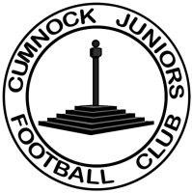
Cumnock Juniors Football Club

Townhead Park
Townhead Street
Cumnock
KA18 1LE
cumnockjuniors@gmail.com

Secretary President Treasurer
Jamie Campbell Kevin Orr J. Mitchell
07545882291 07455778977 07855783136

Cumnock Juniors FC endorses the principles of Equality and is committed to ensure that everyone who wishes to be involved with Cumnock Juniors FC, regardless of their role, current or potential:
- have a genuine and equal opportunity to participate to the full extent of their own ambitions and abilities, regardless of their age, sex, gender identity, disability, marital or civil partnership status, pregnancy or maternity, religion, race, socioeconomic status or sexual orientation; and
- can be assured of an environment in which their rights and dignity and individual worth are respected and valued, and in particular that they are able to be involved and participate without the threat of discrimination, intimidation, victimisation, bullying, harassment or abuse.

For and behalf of Cumnock Juniors Football Club
Kevin Orr, Club President
17 April 2023

